Although not used very often while making web apps

But javascript do have the provision of inheritance

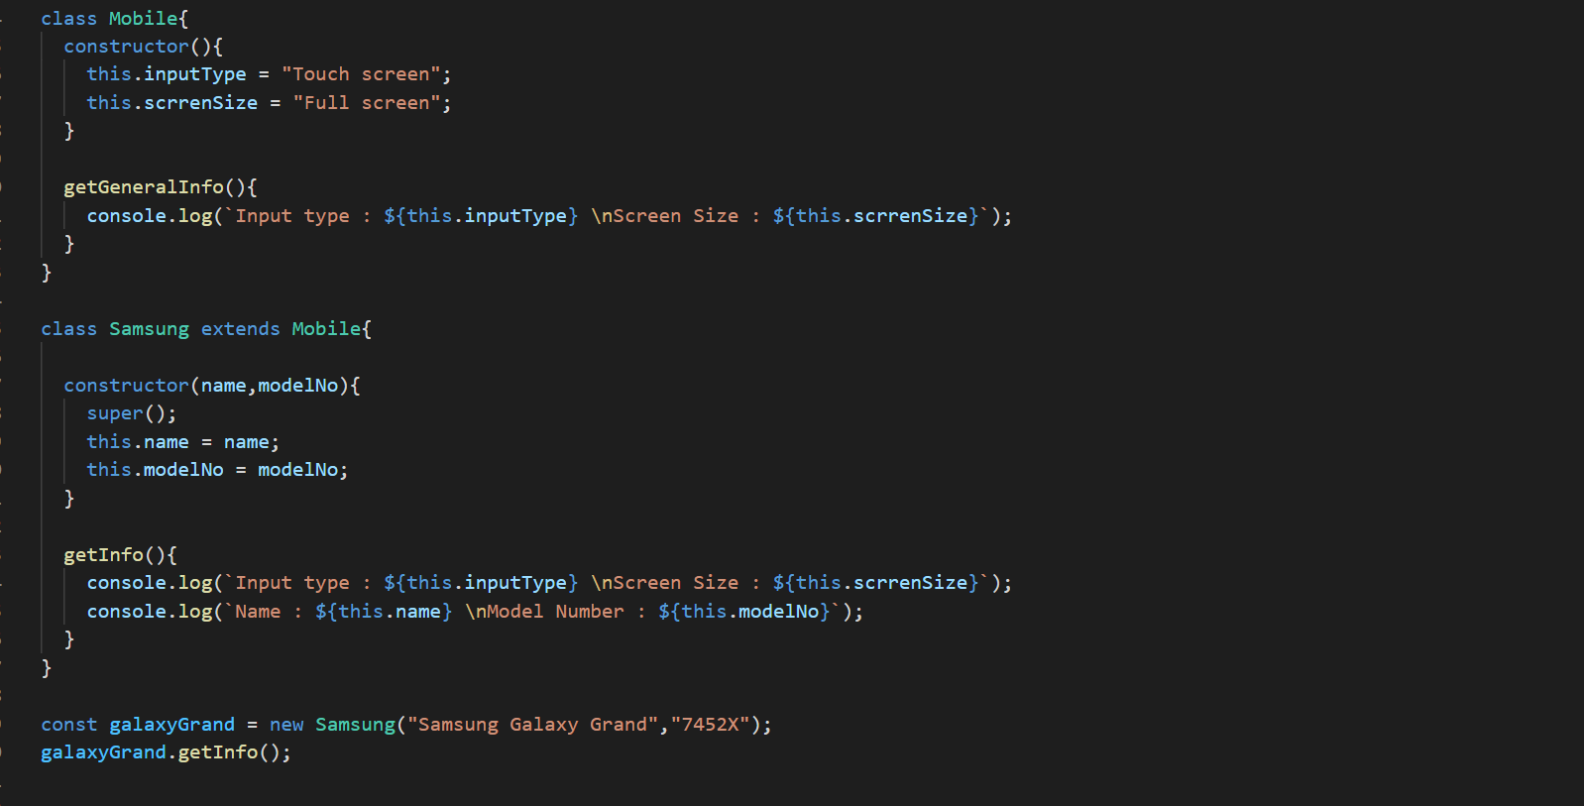

Here first we make Mobile class, where we define all our variables inside constructor and method outside the constructor

Than we make Samsung class

And we inherit the methods and properties of the Mobile class to the Samsung class

**We do this by using “extends” keyword**

**Important Rule**

When object is made, from the lowest class in the inheritance tree first of all the constructor of that class is called

So, from the constructor of the lowest class in the inheritance tree we have to call the constructor of the classes before the last class

**We do this using “super” method, only method we call from inside the constructor**

Above when javascript encounter with the super inside the constructor of the Samsung class the control goes to the Mobile class and it’s constructor.

**So we can also pass data as arguments from super method of Samsung class to the Mobile class’s cocnstructor**